IMPLEMENT HIERARCHICAL CLUSTERING

AIM
To implement the Hierarchical Clustering algorithm using Python to group students based on their hours studied and marks, and visualize the hierarchical relationships using a dendrogram and scatter plot.
ALGORITHM
- Import the required libraries: Pandas, Matplotlib, SciPy, and Scikit-learn.
- Load the dataset from the data.csv file.
- Select Hours_Studied and Marks as input features.
- Create a linkage matrix using the Ward method.
- Plot the dendrogram to display the hierarchical relationships between data points.
- Create an Agglomerative Clustering model with three clusters.
- Fit the model to the dataset and obtain cluster labels.
- Add the cluster labels to the dataset.
- Display the clustered dataset.
- Plot a scatter graph using different colors to represent the clusters.
- Display the dendrogram and scatter plot.
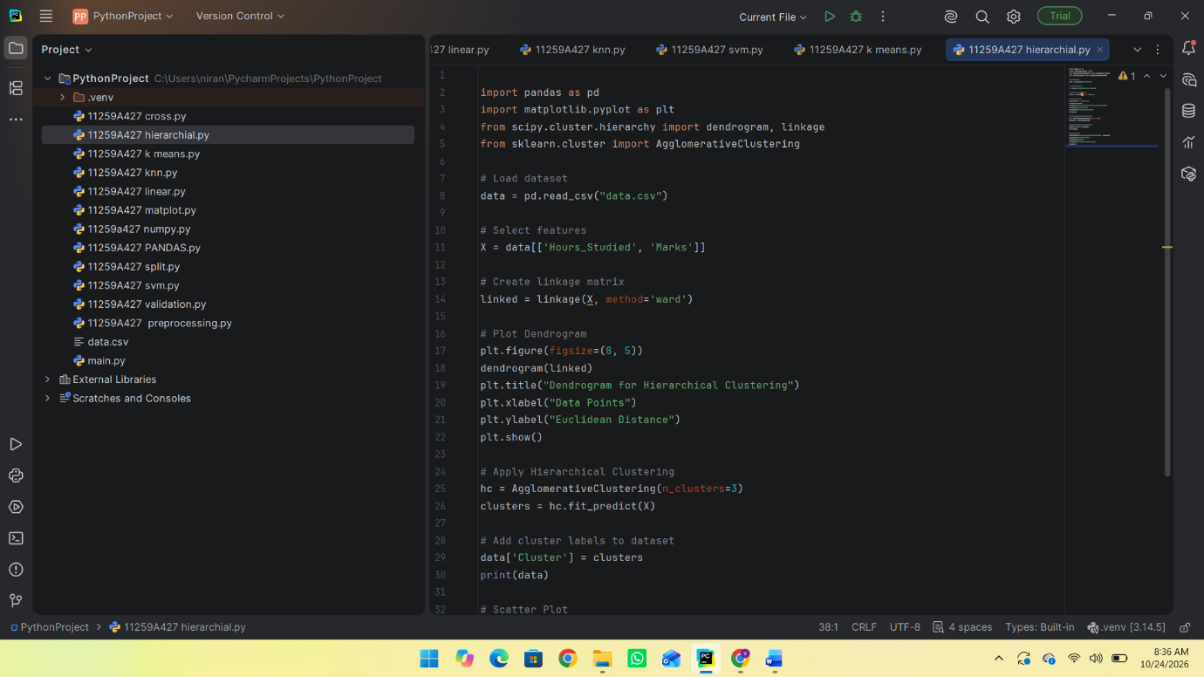
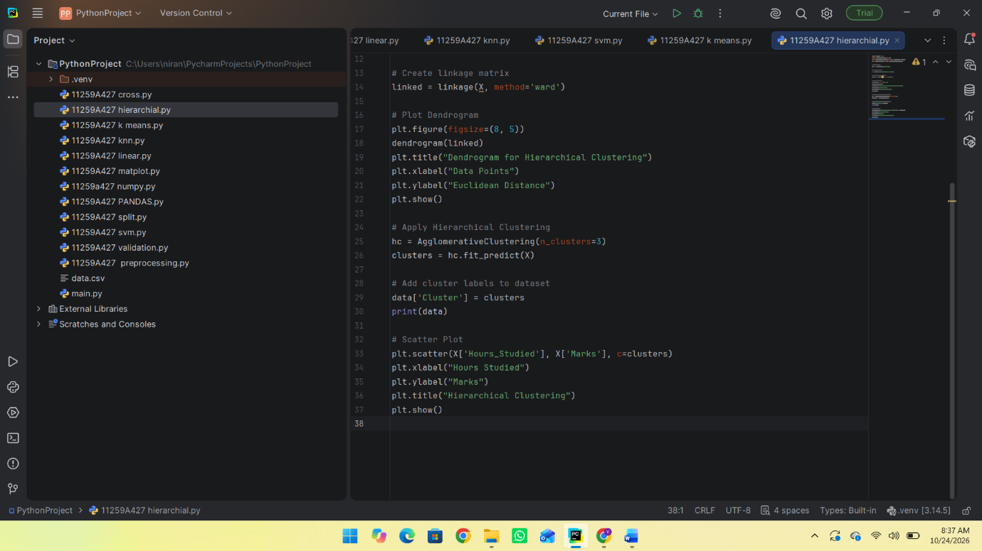
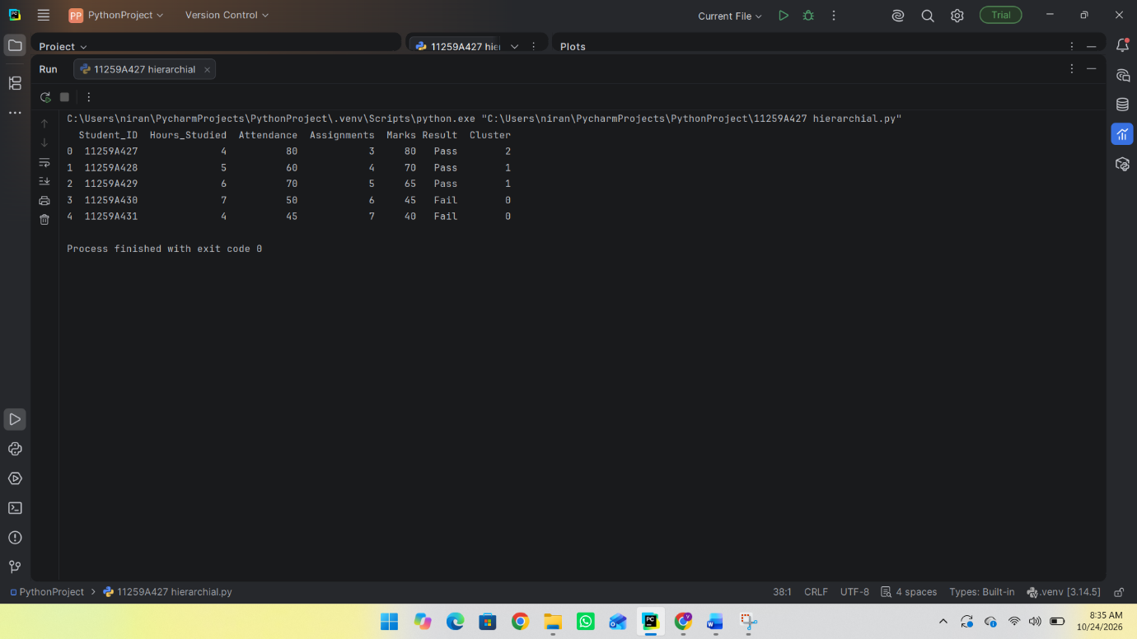
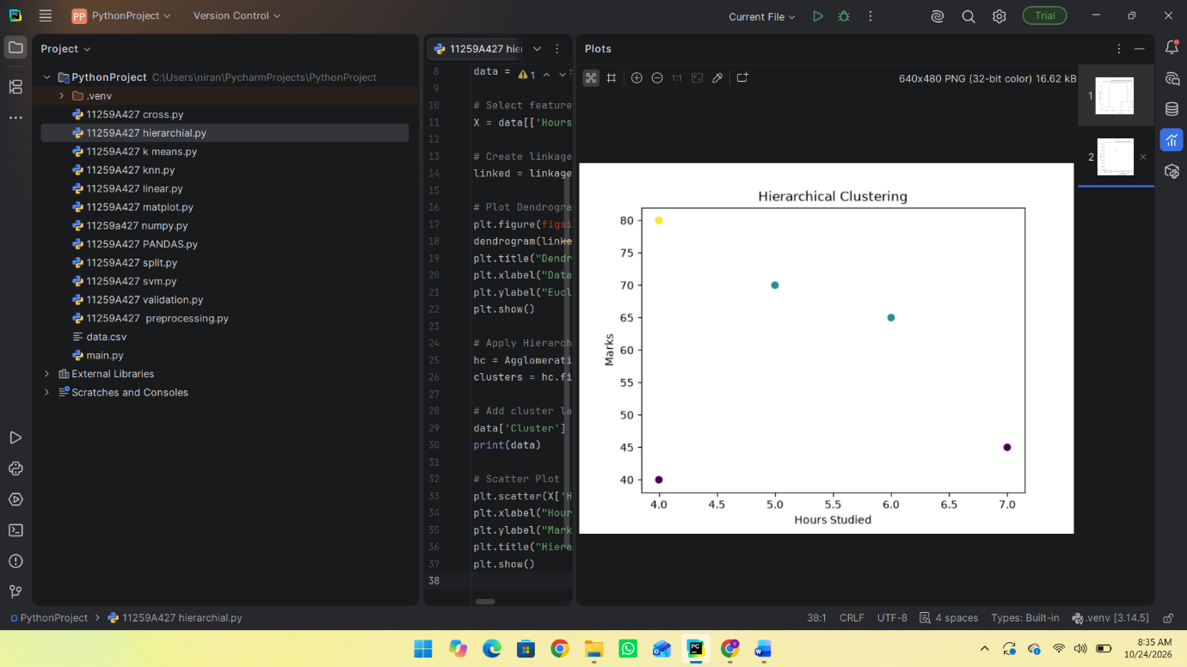
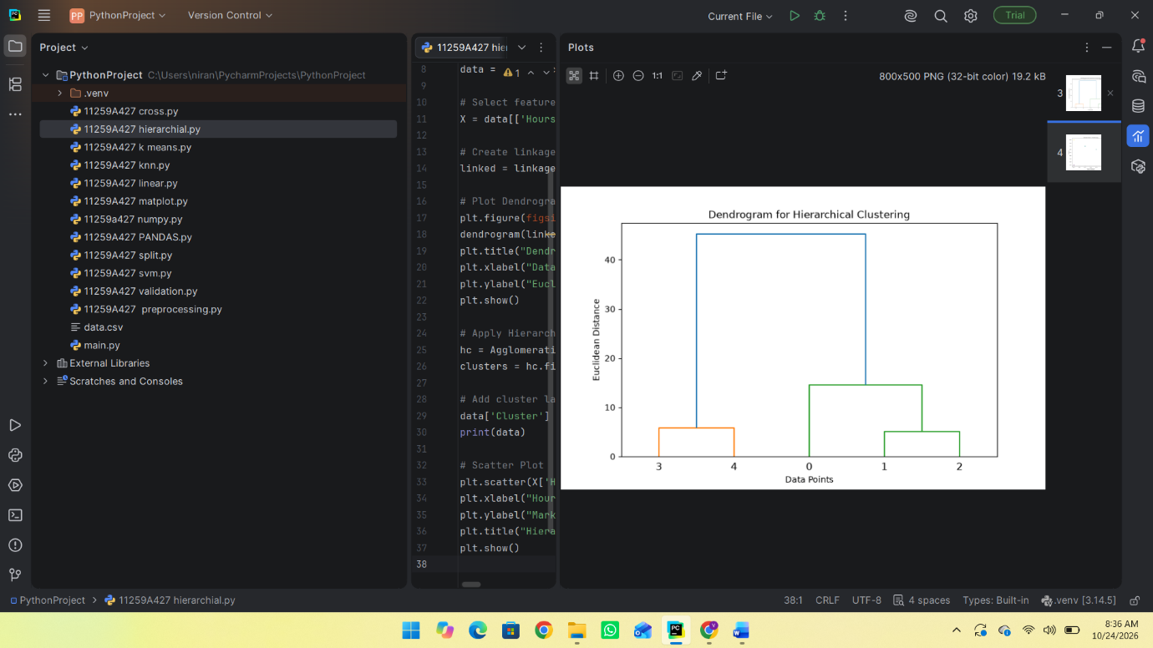

RESULT:
Thus, the Hierarchical Clustering algorithm was successfully implemented using Python to group students based on hours studied and marks. The hierarchical relationships were visualized using a dendrogram, and the identified clusters were displayed using a scatter plot.

